# Quick Start Guide – How to connect to your Wi-Fi network

Overview: We’re going to connect the N0DY Wi-Fi Relay to AC power. It will start up a standalone wireless access point and a standalone web site. We’ll use the access point to make the initial connection to the N0DY Wi-Fi Relay. Connecting your browser to the web site will allow you to configure the N0DY Wi-Fi Relay for your specific Wi-Fi setup.

1. Connect 120v AC power to the single terminal block labelled “J1”. CAUTION: Mains voltages are hazardous and potentially lethal. Do not allow it to come into contact with your body. Do not allow the board traces carrying the AC power to the AC/DC converter to come into contact with other conductors, potentially causing a short circuit. The N0DY Wi-Fi Relay can work with AC input voltages ranging from 100 – 240 VAC.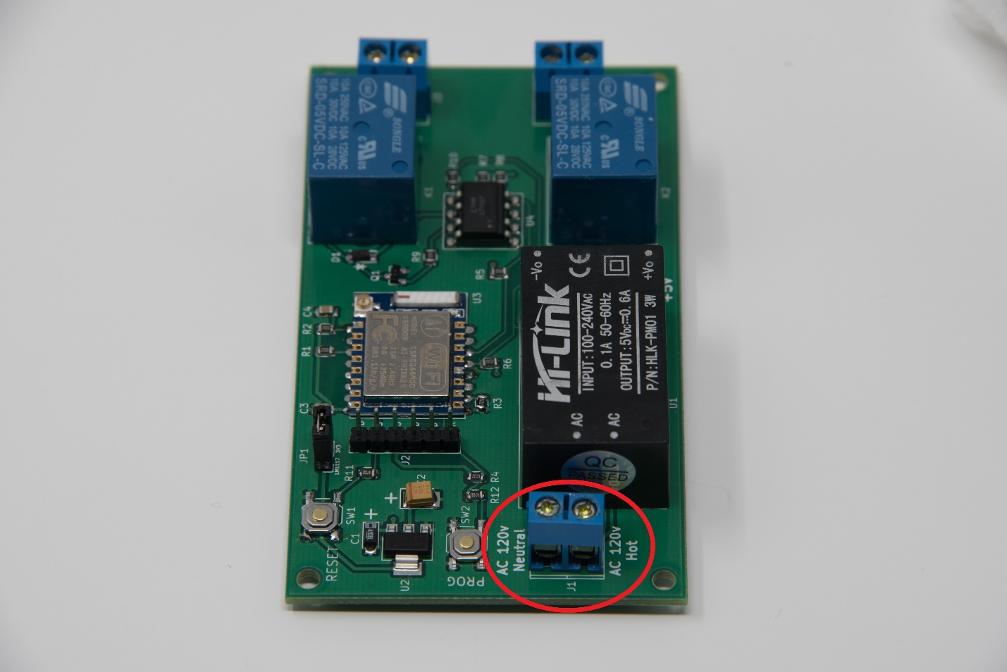
2. The onboard processor (ESP-8266) will start up a standalone Wi-Fi access point (AP), which will allow you make the initial connection to the N0DY Wi-Fi Relay. The standalone AP will have a name starting with “wifirelay-####”. Use your phone or laptop to find the access point and connect to it.
3. Once connected to the access point’s network, access the web page at <http://192.168.4.1>. (It may start up automatically on the Wi-Fi configuration page after connecting). The web server will provide you with buttons to control the state of both relays, menus to configure the device, and provide status and logging information.

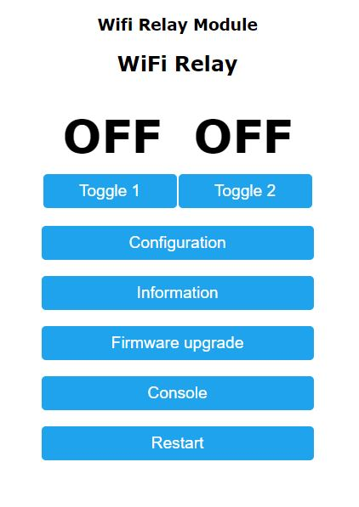

1. To connect the N0DY Wi-Fi Relay to your home Wi-Fi, go to the Configuration menu, and select the Configure Wi-Fi menu item. There you will find a link to click to scan for available Wi-Fi networks. There are places to make entries for two Wi-Fi access points (APs) (although only one is needed – the second is a backup). Enter your network’s SSID and password in the fields provided. You can also give your N0DY Wi-Fi Relay a hostname to use to refer to it. The default is the same as the access point name used earlier, “wifirelay-####”, where # represents decimal digits.  
     
     
   Before you hit save, be aware that you’ll need to be able to find the IP address that gets assigned to your N0DY Wi-Fi Relay in order to be able to communicate with it. This is highly dependent on how you have your network set up. You might be able to refer to it simply with the hostname you provided in the Wi-Fi configuration, as in <http://your-hostname-here>. In other cases, you might have to check your Wi-Fi router/WAP to see what IP address was assigned. If you go this route, you can access the N0DY Wi-Fi Relay with <http://your-ip-address-here>.

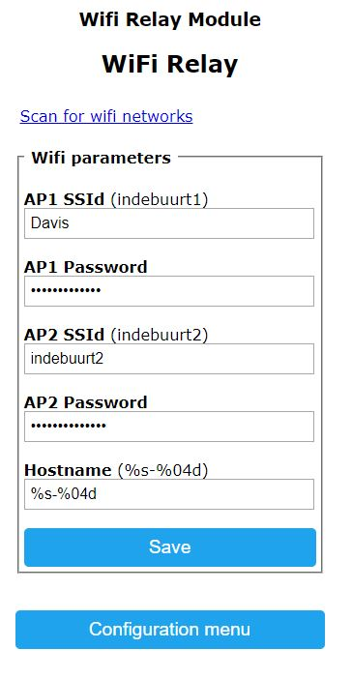

1. Click Save. You’ll then need to reconnect by pointing your web browser to one of the address forms discussed in the previous step. Once this is done, your N0DY Wi-Fi Relay is controllable via its web page over your Wi-Fi network. You can now turn on and turn off the two on-board relays by means of the device’s web page.

MQTT is disabled by default. If you have access to an MQTT server, use the “Other” configuration page and select the Enable MQTT option. This will then restart the module and a new MQTT Configuration option will become available.

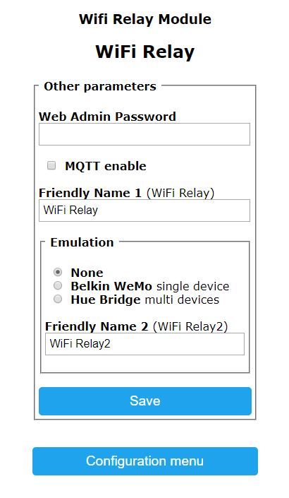

This is a very basic setup. There are many, many more capabilities of the N0DY Wi-Fi relay. See “Hardware Users Guide”, “Software Users Guide”, and “Hacking the N0DY Wi-Fi Relay” to explore these capabilities further.

Questions? Help Needed? Contact Me!

[jeff@n0dy.com](mailto:jeff@n0dy.com)